These are the instructions to the code for automated google forms for GDS made by yours truly: Jorge Pineda, Fall 2024.

Any updates to the code specify below and state your name and semester of making updates:

____ ____ _____

HERE ARE THE INSTRUCTIONS:

This is the link to the form with the original code: <https://docs.google.com/forms/d/1Ns4Gjiw8NV4ALqtHVWmfNrP7TKekzQdgy-jmQbAkPW0/edit>

This will take you to this place:

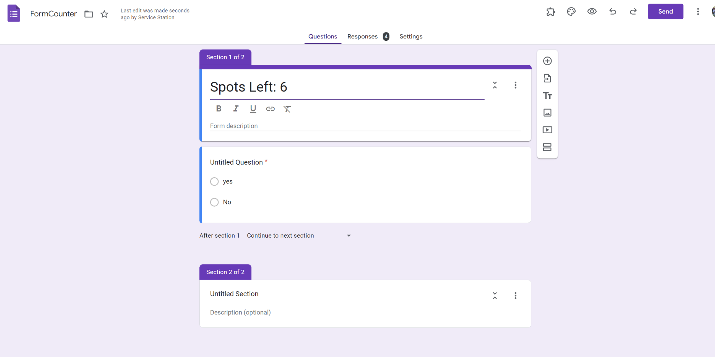

To access the code you need to go into the script editor:

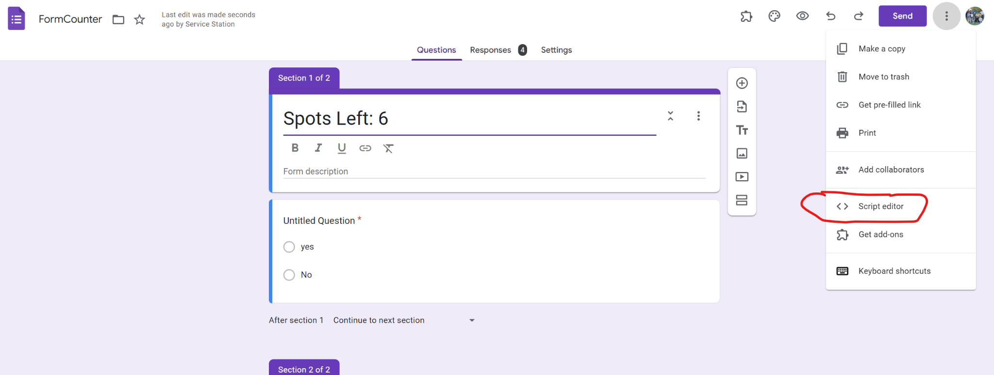

Next you will see a series of things, but don’t worry. We’ll go through each step. 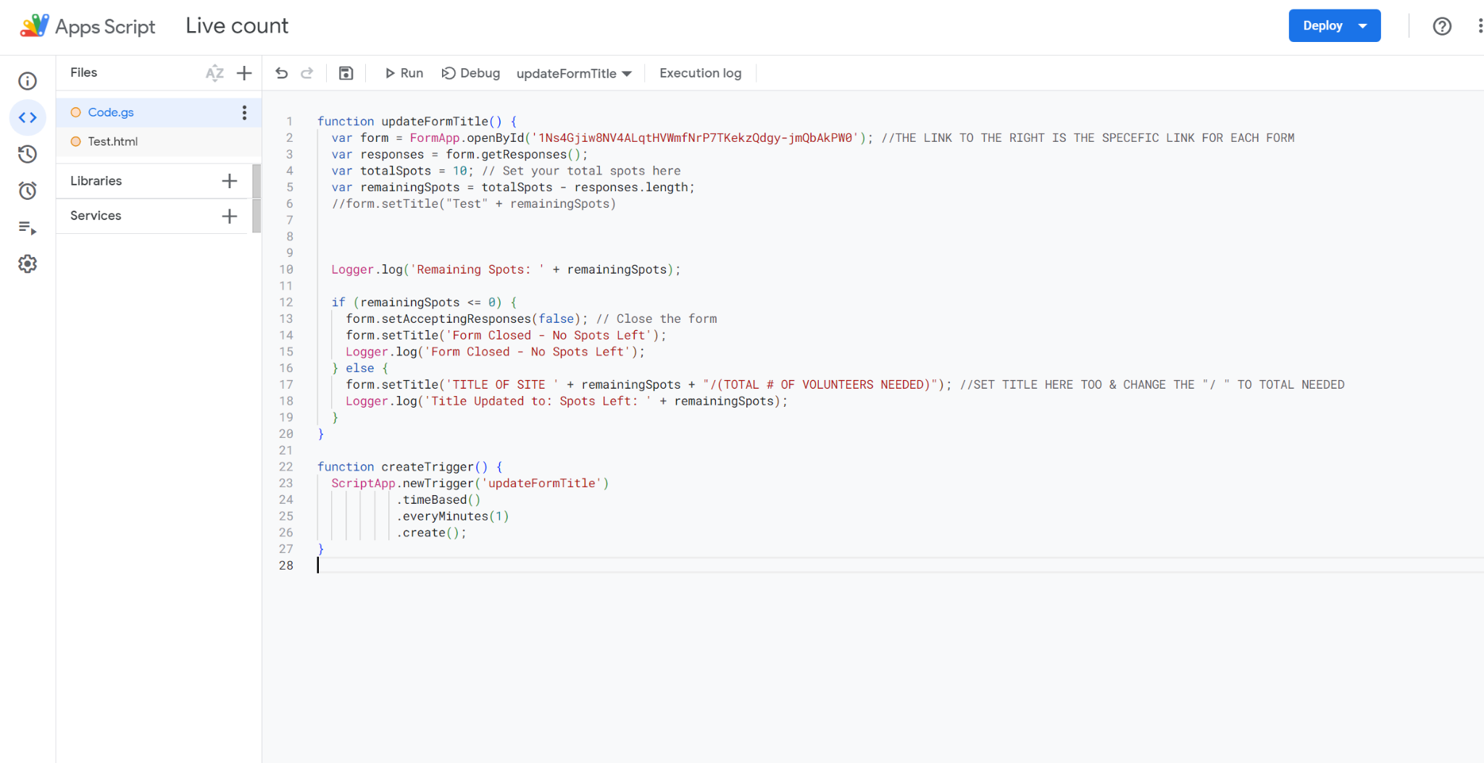

This is what you are met with. The code in Code.gs is the main code that will help with updating the form. You will copy this WHOLE thing and paste it into your desired form’s script editor.

-it automatically has things that tell you what to edit, I will go through example later if

needed

Next is the HTML, the front end of the code.

You will click the + sign and add an HTML because it will not automatically put it in IN YOUR PROJECT

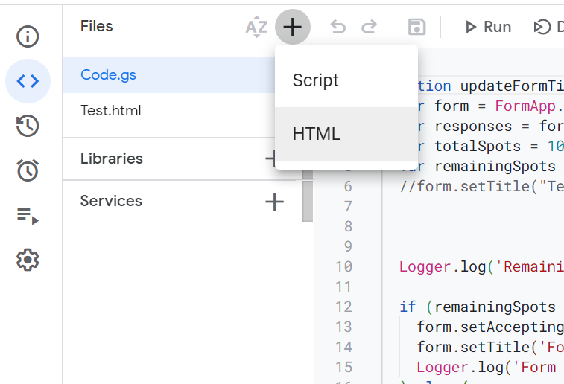

The title is arbitrary, just make one and title what you like.

You will click on Test.html in the original doc where you find the code for the HTML to add onto YOUR project

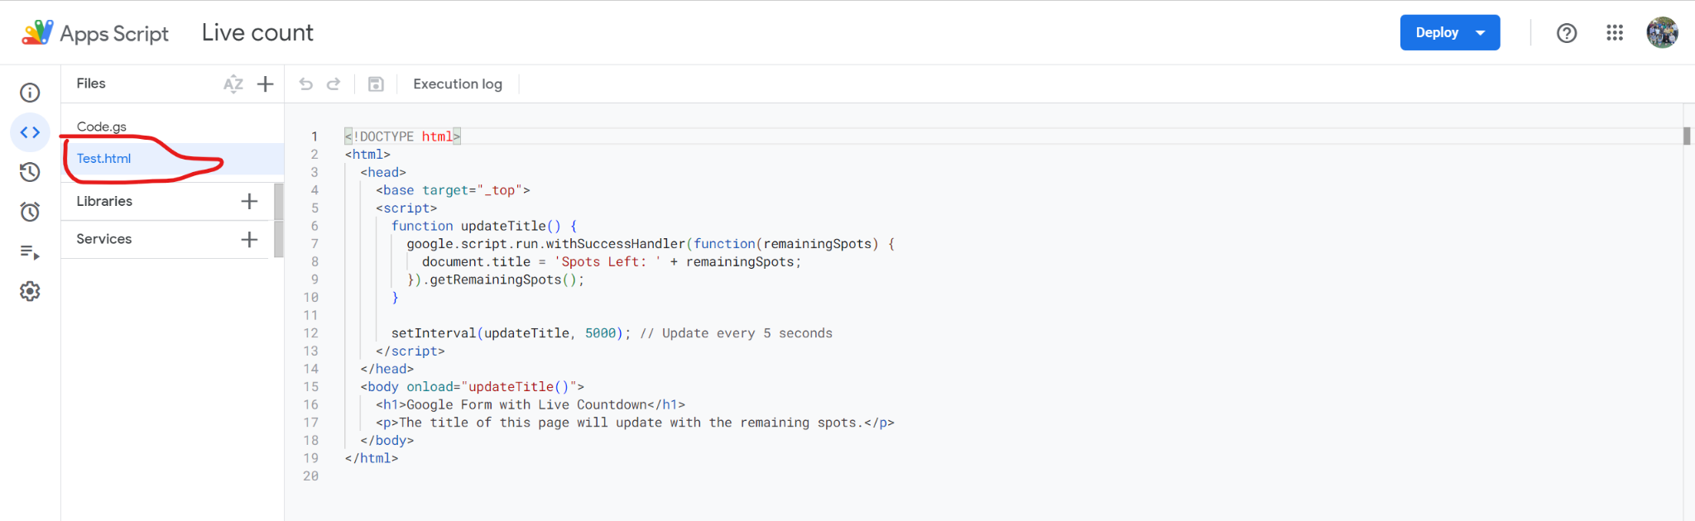

Copy and paste original code into new HTML you just made in your project and change to your fitting.

Next you will deploy to add trigger. Click on deploy top right and do the following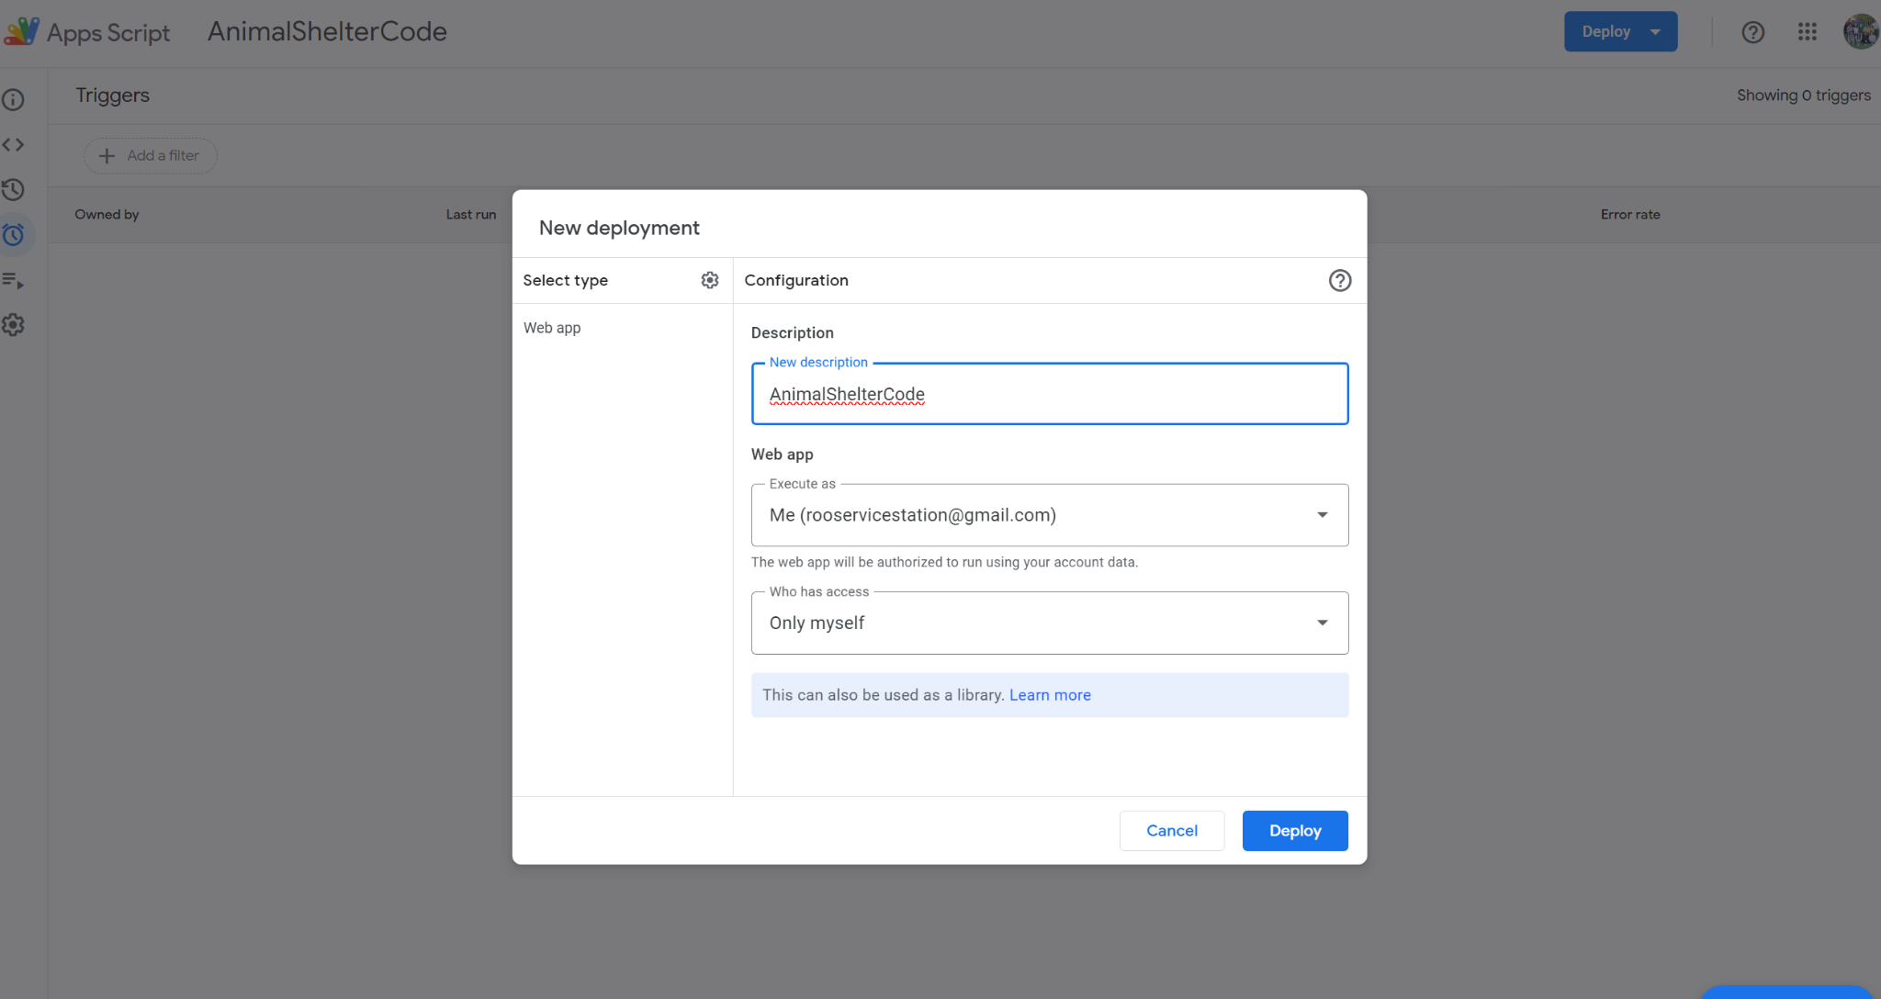

Select type and click web app. Then name the title to the corresponding form. Then keep options as seen and hit deploy. Authorize the access and boom (yes it’s fine I am not hacking your computer) Click done when you finished

NEXT you will make a Trigger that will automatically update forms based on responses.

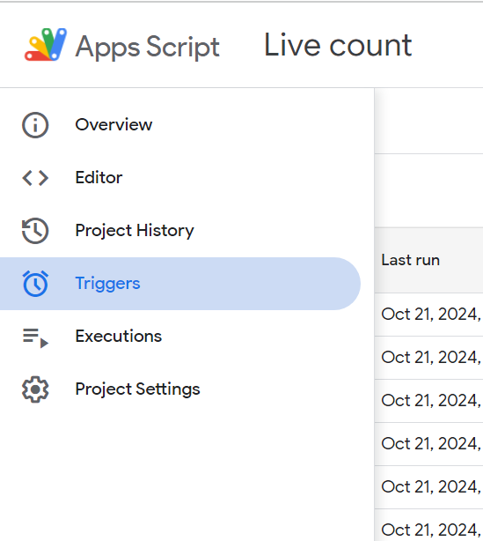

You will want to click on triggers on the left side.

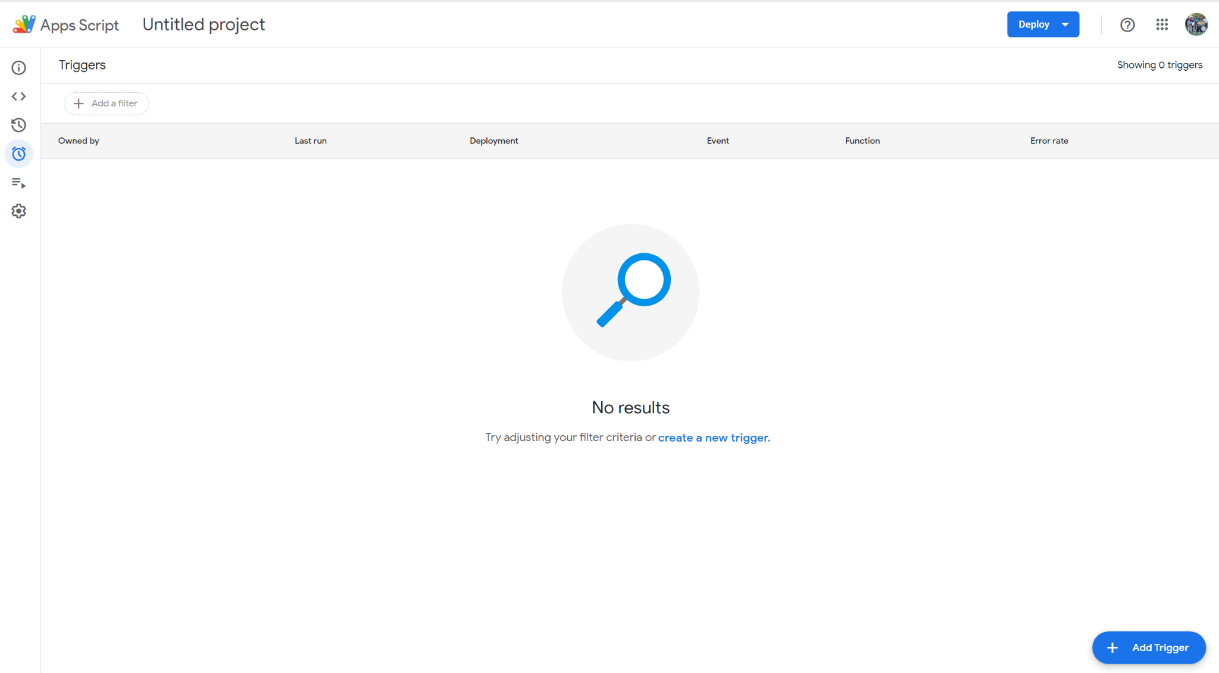

You will want to click add trigger in bottom right in the blue.

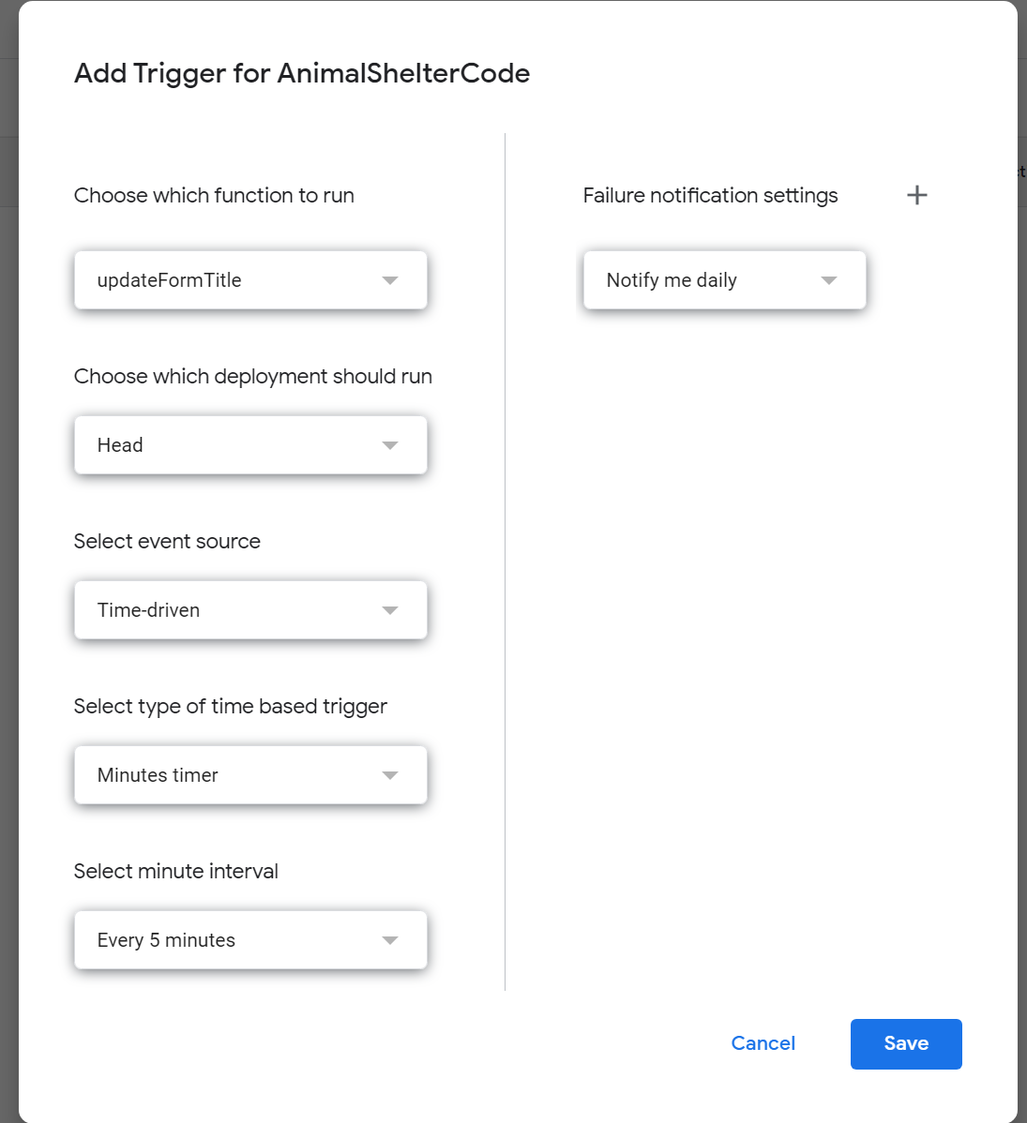

Make sure settings are the same

Then click save

NOW you will go back to editor with Code.gs and click RUN

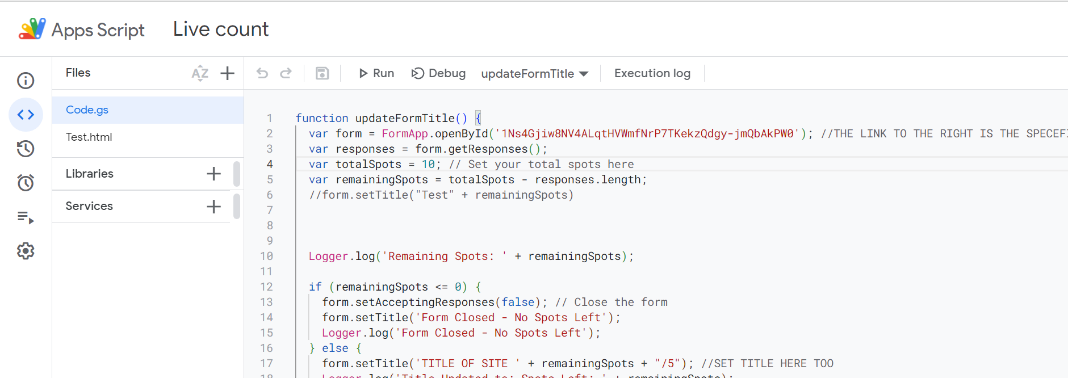

Once you click run you will see these logs

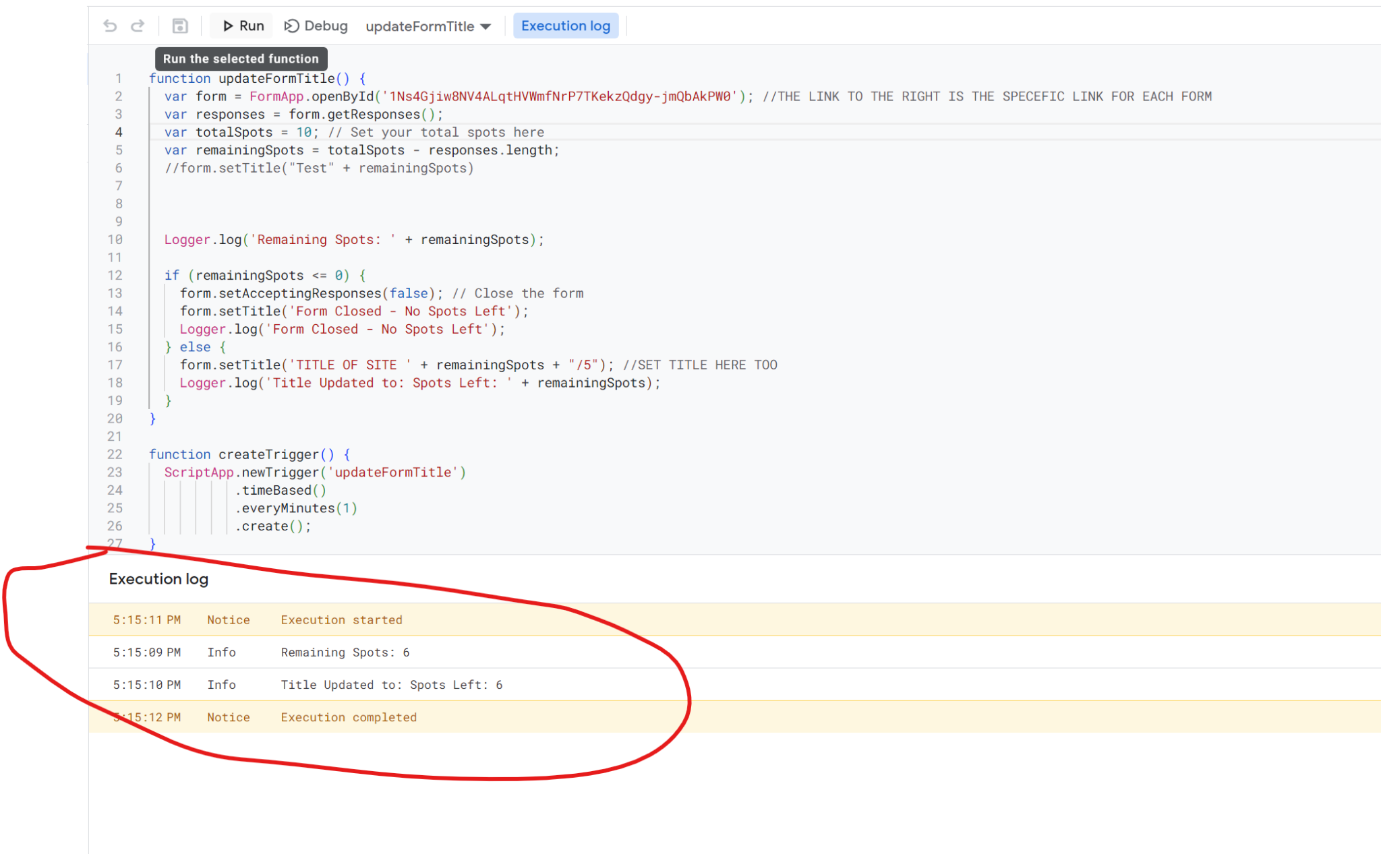

That means it’s running correctly. You can test by filling a form out and it should update within a minute.

That concludes the instructions. Below is an example to help if you are having trouble

**EXAMPLE TO HELP**

We will use Texoma Crisis Center 2024 as an example.

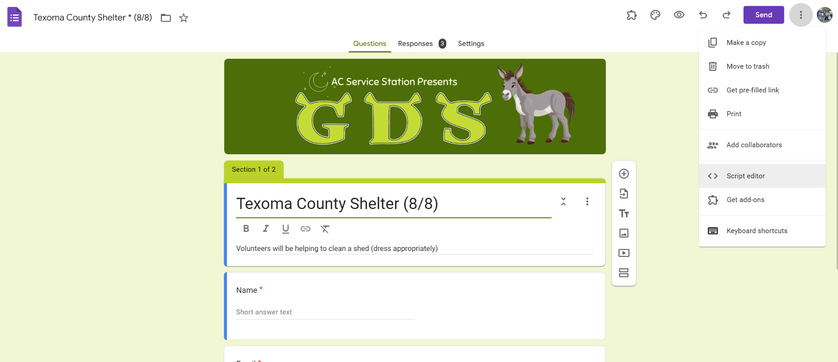

Copy Code.gs from original code from “FormCounter” (link above):

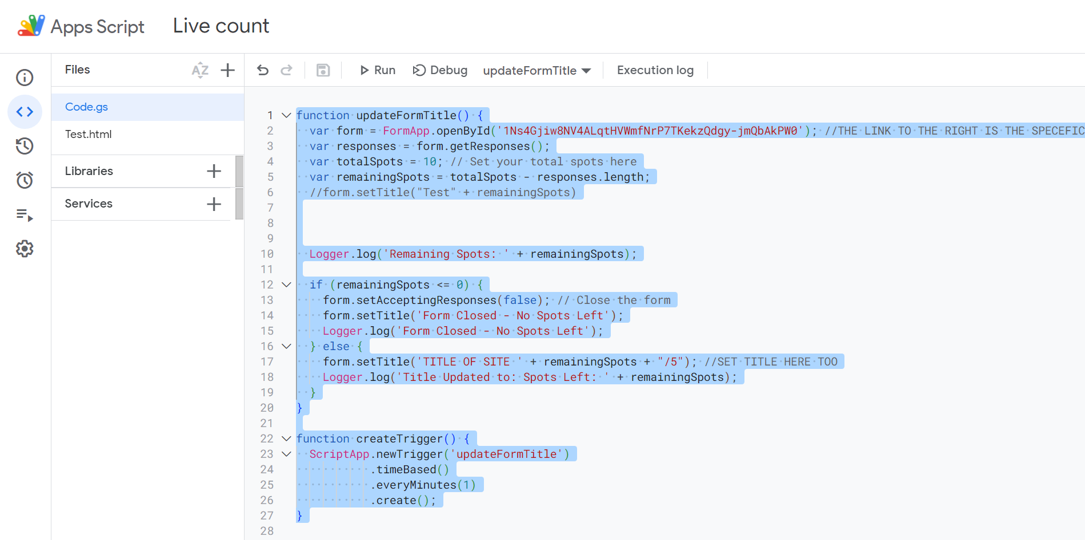

Paste into your form’s empty script editor:

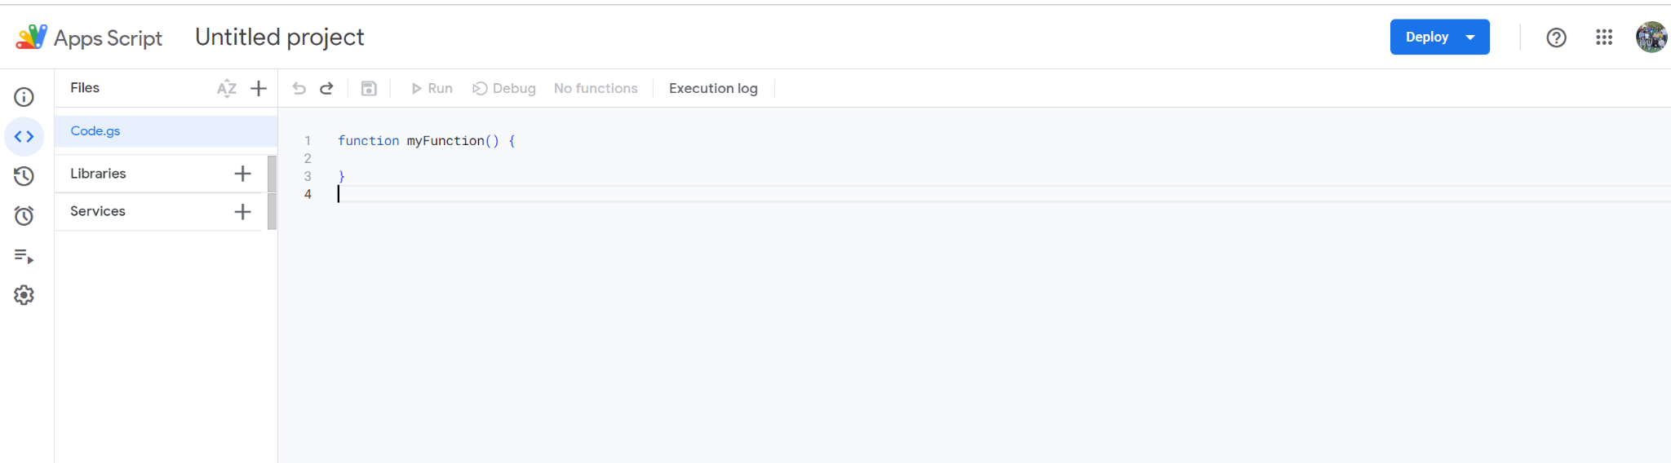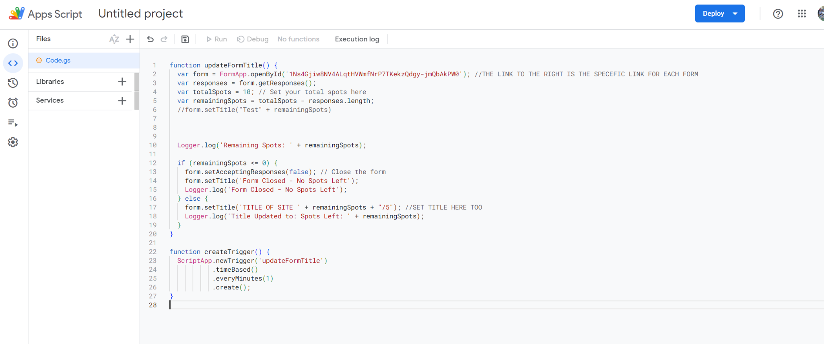

Next we update code in Texoma Crisis Center to fit it’s needs

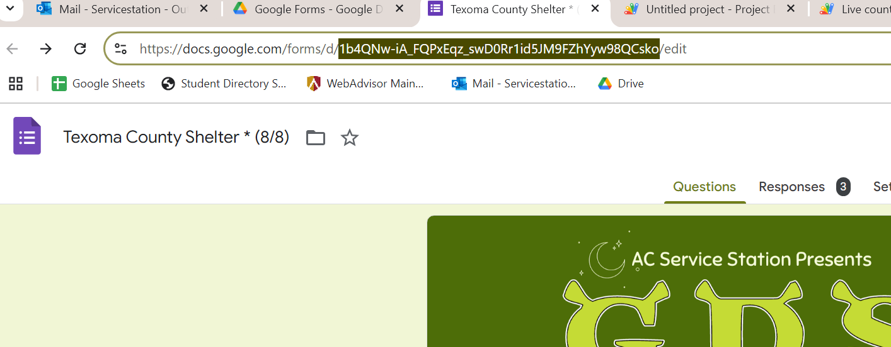

Copy THIS PART of the form, right after /d/ and before /edit

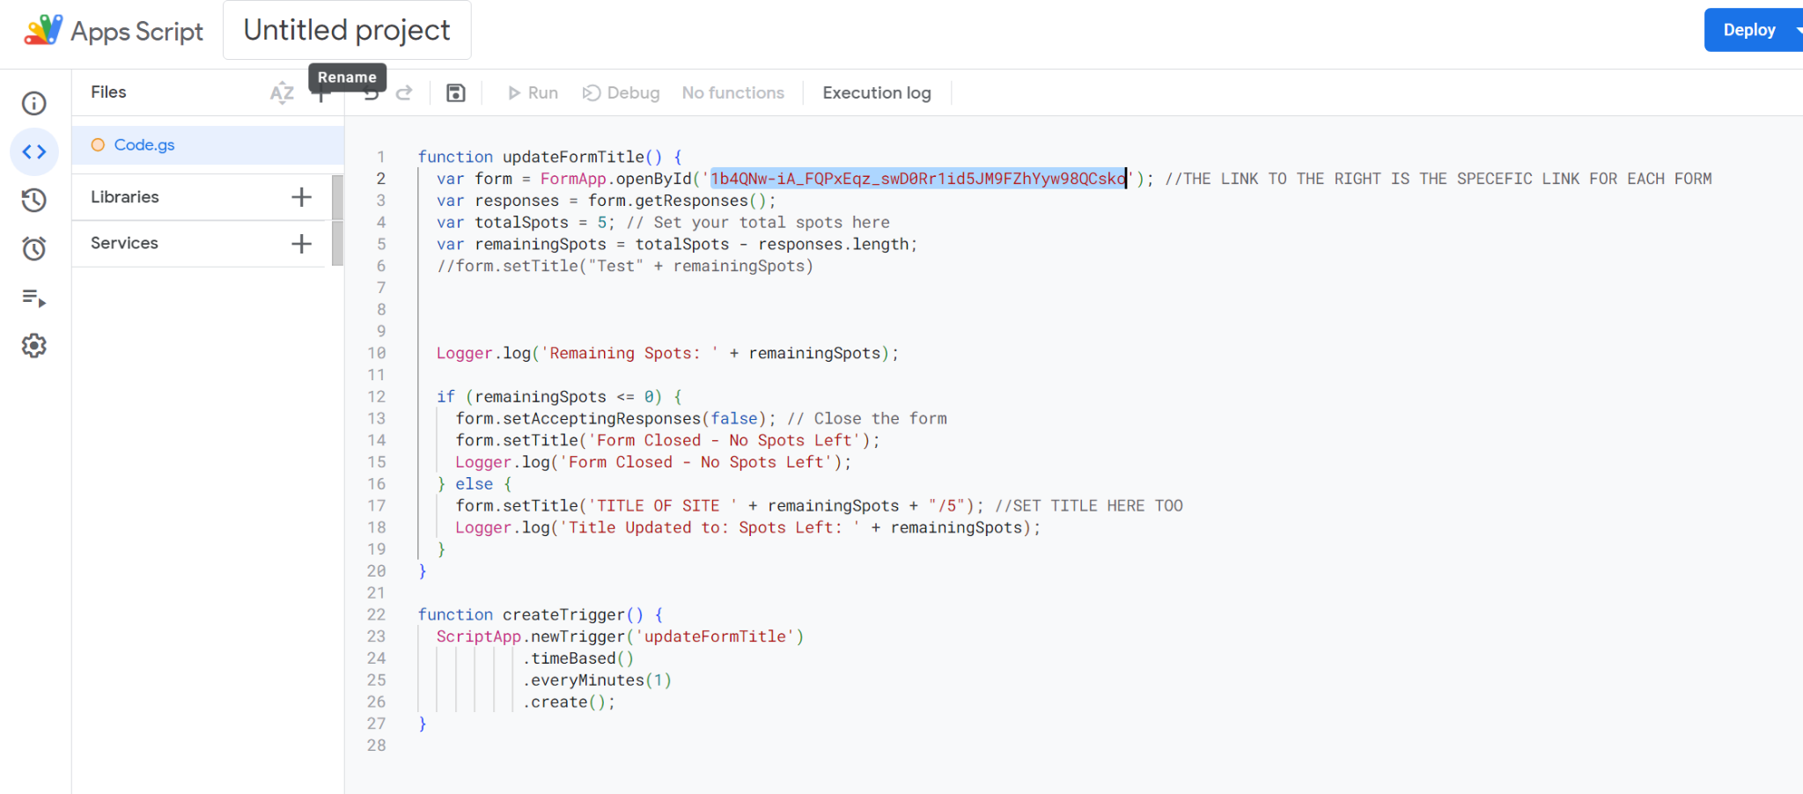

Paste into this part of the code

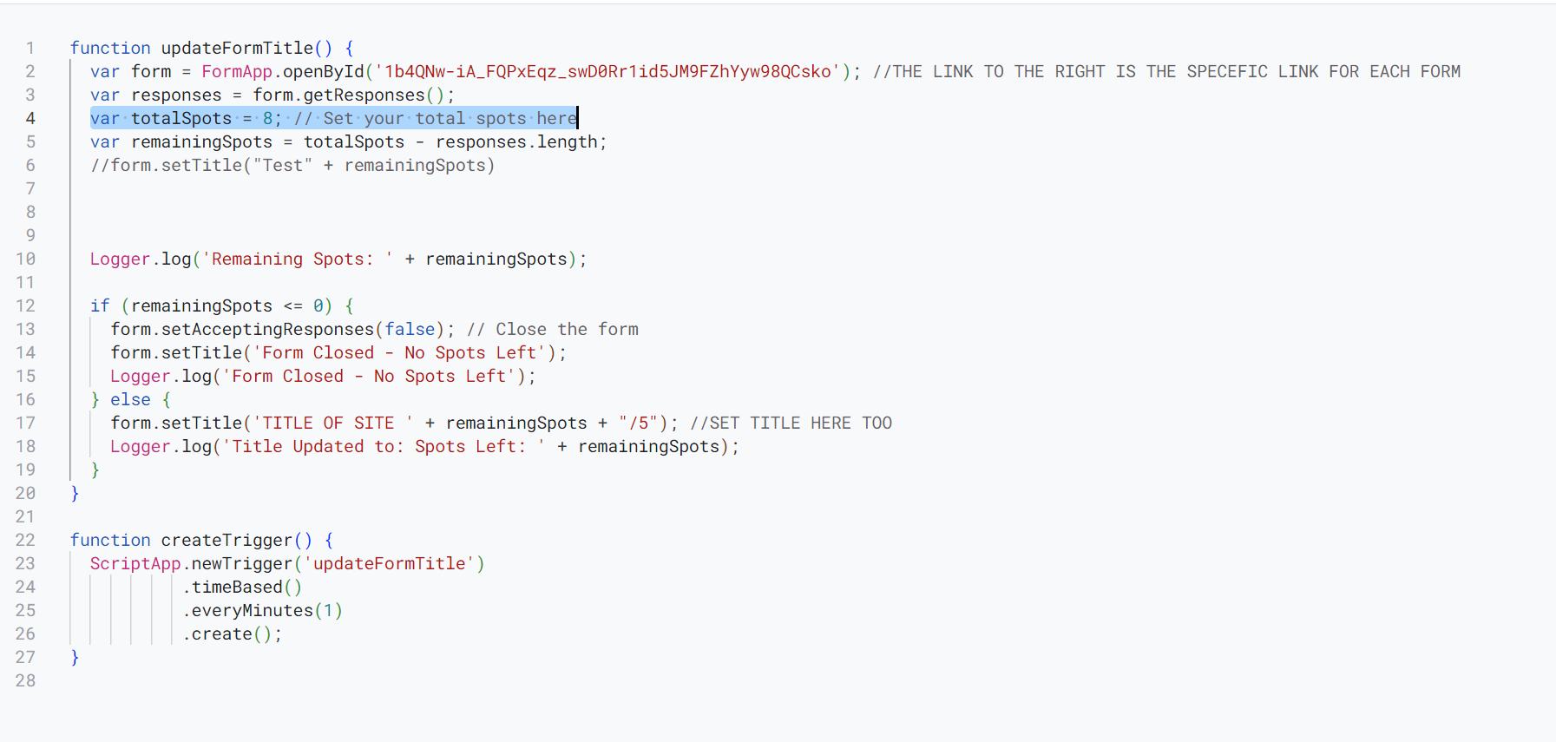

Update the total # of spots to fit the site

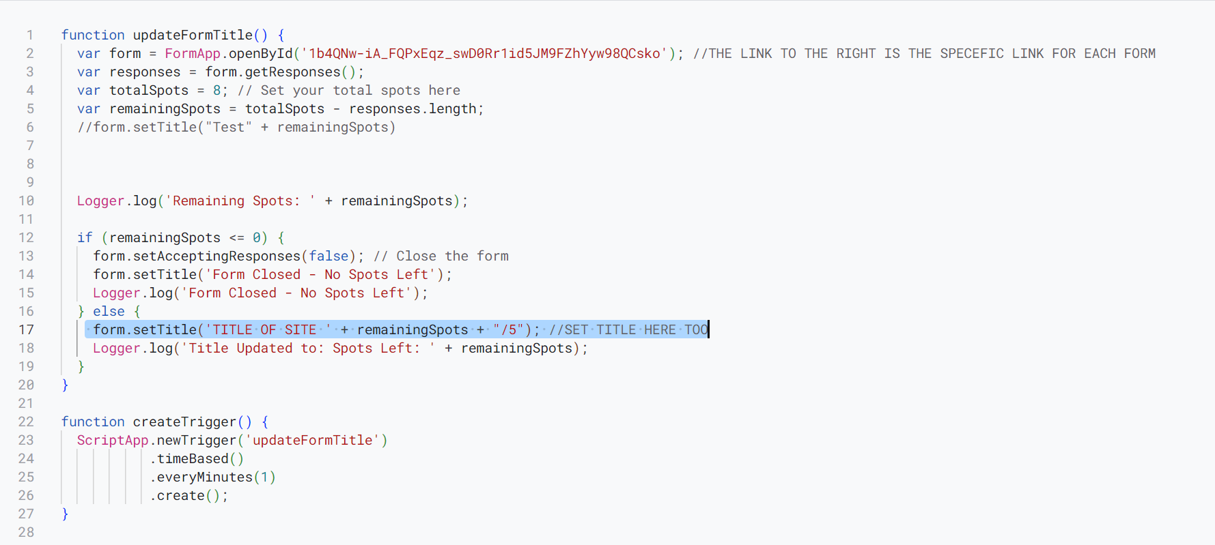

Update the title and change the /5 to /# of spots total

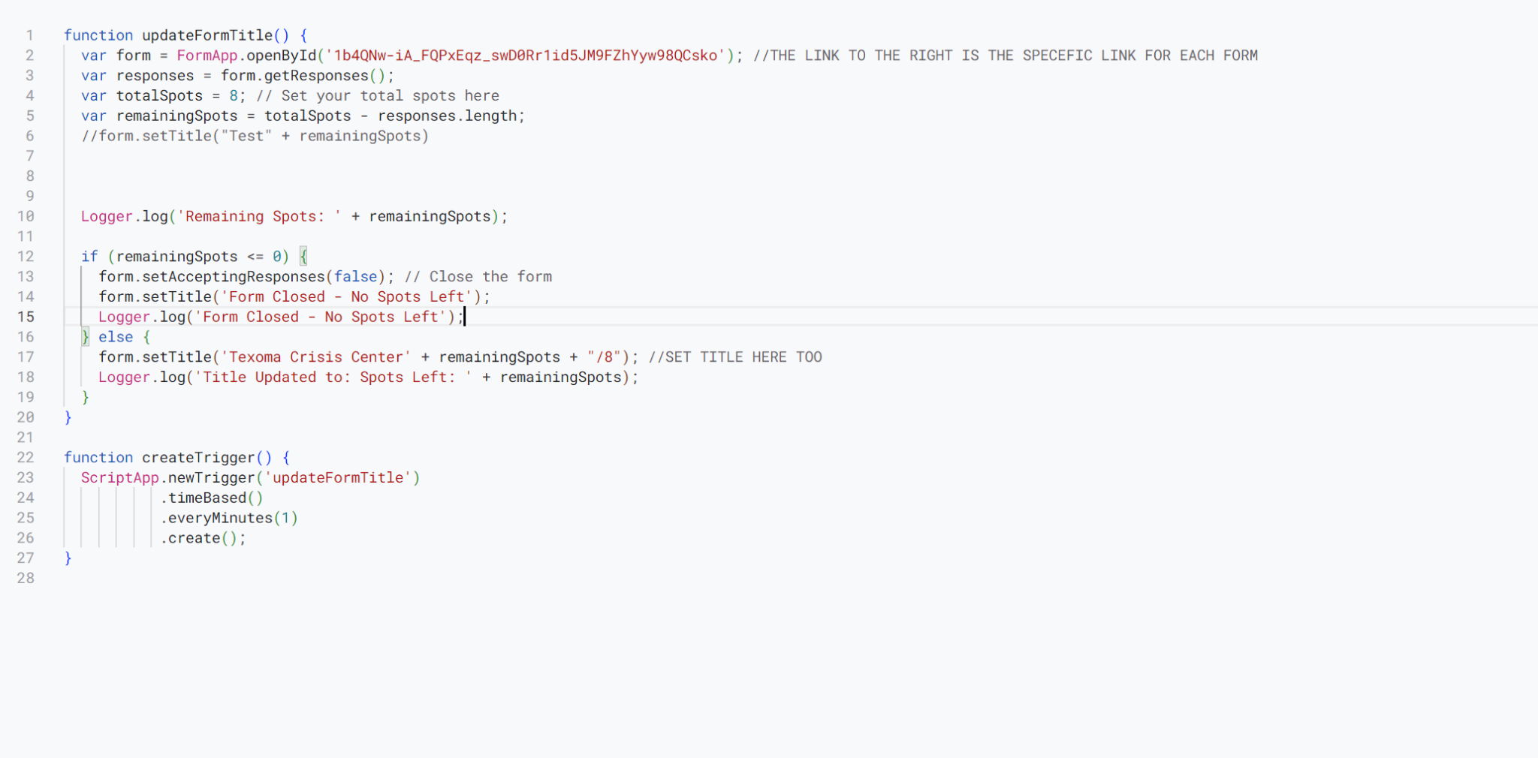

Now you are finished with Code.gs.

Now we add a HTML like we did earlier

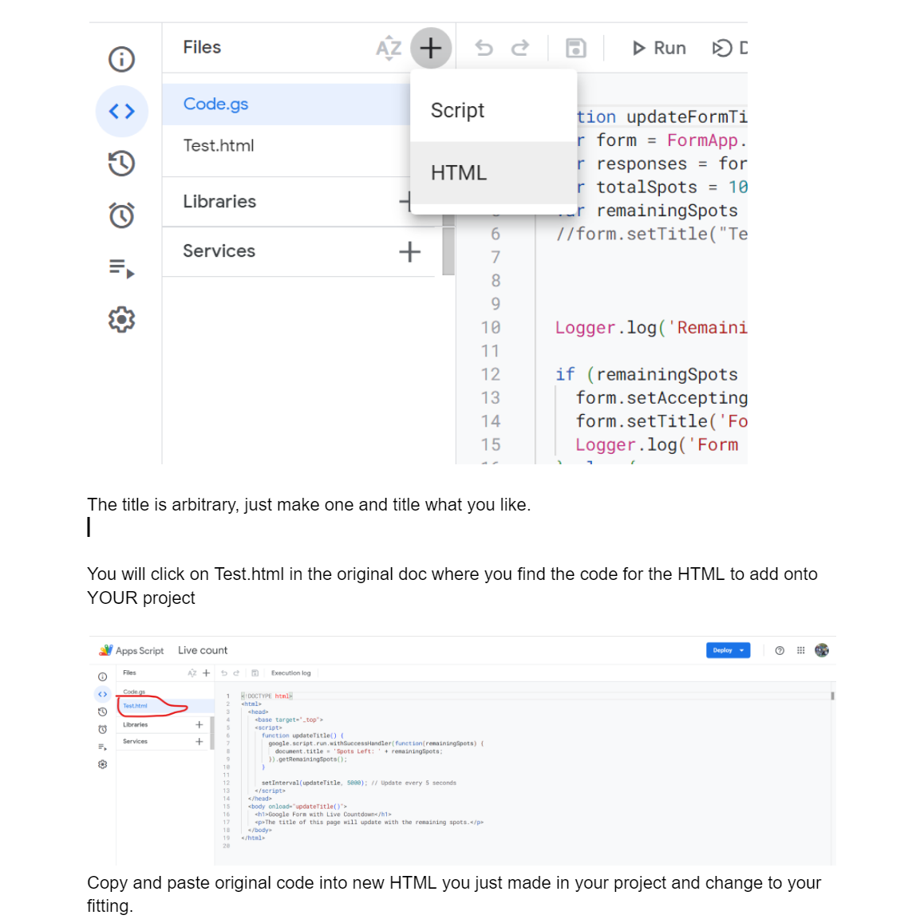

Change to HTML to your fitting

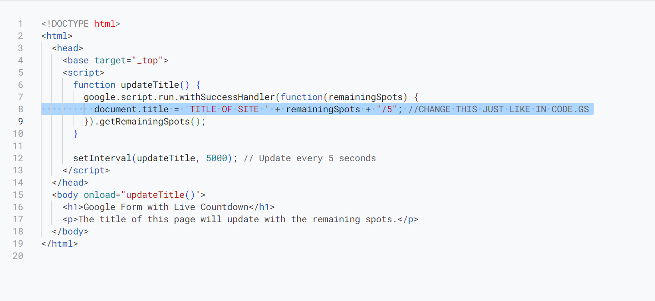

Change title and /5 to /# of total spots in HTML code to fit the site:

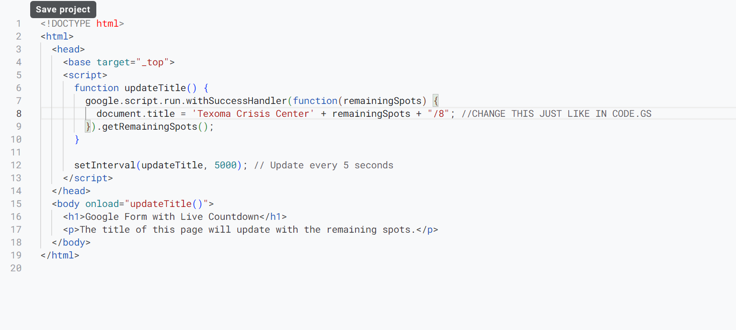

Now deploy the code after saving it with Ctrl + S:

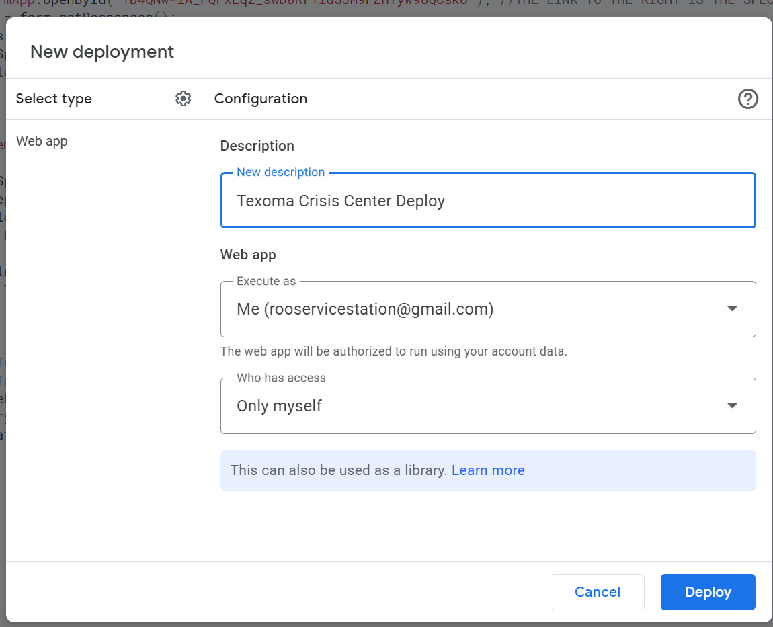

Now add a trigger as stated above:

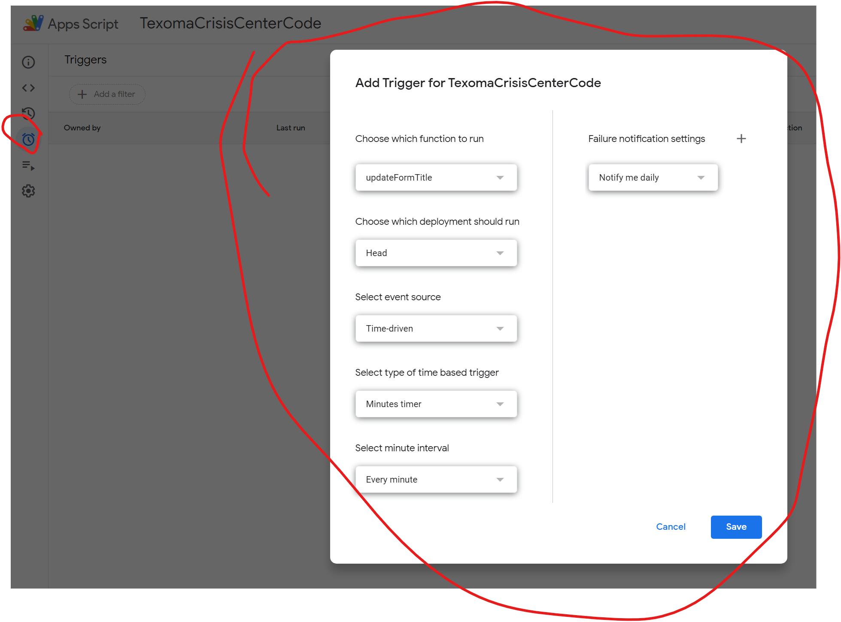

Keep same settings in every form

Now click Run in Code.gs and make sure no errors:

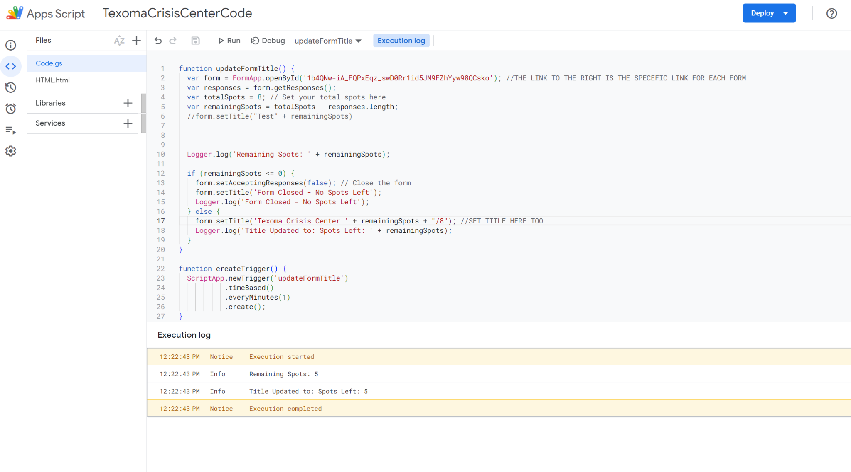

Then your form will now update based on total spots and close automatically when it’s full! (I think)

IF CODE DOESN’T WORK: Call Jorge (956) 408-5230